The 7th Asian Young Guns Challenge
Korea 2015 - Seoul Racecourse – Saturday August 29

The Korea Racing Authority (KRA) will host the 7th Asian Young Guns Challenge at Seoul Racecourse on Saturday August 29, 2015.

First held by the Victoria Racing Club at Flemington Racecourse in 2009, Asian Young Guns brings together eleven of the most exciting young jockeys in the Asia Pacific Region who this year will compete in a four-race series in the Korean capital.

History
Year | Host Nation/Club | Racecourse | Winner
2009 | Australia (VRC) | Flemington | Kota Fujioka (Japan JRA)
2010 | Singapore (STC) | Kranji | Derek Leung (Hong Kong)
2011 | Australia (VRC) | Flemington | Jordan Mallyon (Australia)
2012 | Macao (MJC) | Taipa | Alvin Ng (Hong Kong)
2013 | New Zealand (NZTR) | Te Rapa | Harry Kasim (Singapore)
2014 | South Africa (GCTC) | Clairwood | Tham Kin Chong (Malaysia)

Venue

Seoul Racecourse (officially known as Lets Run Park Seoul) is operated by the KRA, Korea’s sole racing authority. Located just south of Seoul in the city of Gwacheon, it was built for the equestrian events of the 1988 Seoul Summer Olympics and was converted into a racecourse after the conclusion of the Games.

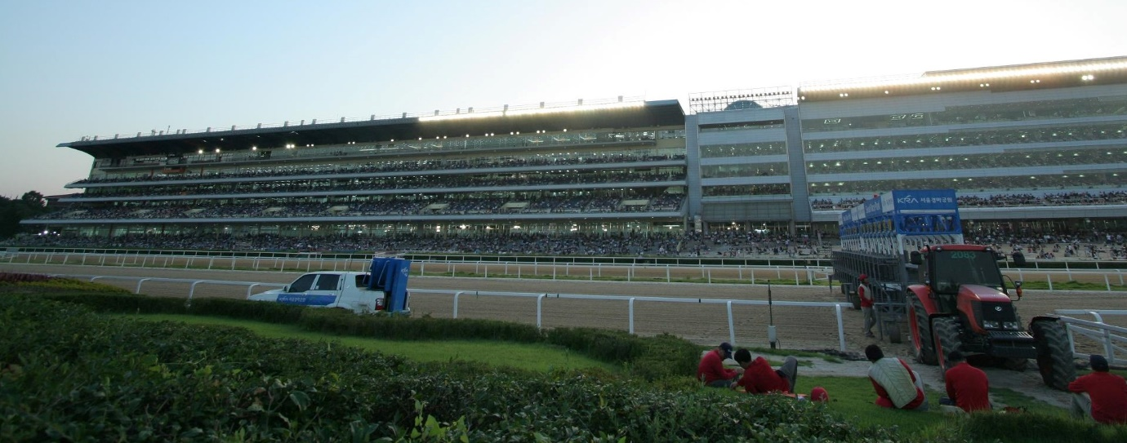

The track surface is sand and the grandstands can accommodate up to 60,000 racegoers. Approximately 30,000 are expected on Challenge day.

Seoul Racecourse is the venue for most of Korea’s top races, including the Korean Derby, the President’s Cup and Grand Prix Stakes, as well as the Asia Challenge Cup International Invitational race, which will take place the day after Young Guns.

The Races & Riders

All jockeys will ride in four races. Mounts will be allocated by means of a draw.

  - Points will be allocated to jockeys whose horses finish in the first 8 positions, ranging from 25 points for a win to 1 point for 8th
Placing | 1st | 2nd | 3rd | 4th | 5th | 6th | 7th | 8th
Points | 25 | 15 | 10 | 7 | 5 | 3 | 2 | 1
    - If a horse is scratched after acceptance time, the affected rider shall be awarded 6 points. This is equivalent to half-way between 4th & 5th placing.
  - The jockey accruing the highest total points after 4 races will be declared the winner and will receive a trophy and the title of ARF Top Apprentice Jockey of 2015.
    - In case of a tie, the jockey with higher placing on more occasions will be determined to be a winner.

Heat # | Race # | Time | Distance | Class / Conditions | Prize Money
1 | 4 | 14:15 | 1000M | Class 4 Handicap for Korean bred horses with a local rating of between 41-55 | KRW 55 Million
2 | 5 | 14:40 | 1400M | Class 4 Handicap for Korean or Overseas bred horses with a local rating of between 41-55 | KRW 55 Million
3 | 7 | 15:30 | 1200M | Class 5 Handicap for Korean bred horses with a local rating of no higher than 40 | KRW 40 Million
4 | 9 | 16:20 | 1400M | “The Singapore Turf Club Trophy.” Class Open, Weight for Age. For horses with a local rating of no higher than 105 | KRW 150 Million

Prize money is allocated as follows:
Placing | 1st | 2nd | 3rd | 4th | 5th
Percentage (%) | 55 | 21 | 14 | 6 | 4
- Jockey’s share is 6.23% of the prize money for each placing which is subject to tax and an 18% deduction for the Jockeys Welfare Fund

Eleven riders representing nine different racing nations will take part (see next pages for a detailed profile):
Name | Representing
Jye McNeil | Australia (VRC)
Wong Ho Nam, Jack | Hong Kong (HKJC)
Fuma Matsuwaka | Japan (JRA)
Tsubasa Sasagawa | Japan (NAR)
Dong Soo Kim | Korea (KRA, Seoul)
Hee Won Jo | Korea (KRA, Busan)
Yee Mo Choi | Macau (MJC)
Wong Kam Chong | (MRA) Malaysia
Joshua Oliver | (NZTR) New Zealand
Zhi Yong See | (STC) Singapore
Craig Zackey | (SAJA) South Africa

Name  (Country) | Photo | Personal  Information | Riding  Experience | Race Result (1st /2nd /3rd, Win Ratio)
Jye McNeil  (VRC)  Australia | 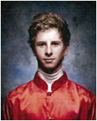 | Born: 9 Dec. 1994.  Height 173cm  Riding Weight 50kg | 4 years (2011~) | · This year: 32 (2/3/2, 6%)  · Last Year: 694(46/61/50, 6%)  · Lifetime: 2384(201/219/245)  ※ Lord Reims Stakes(GⅢ) Winner  ※Wilson Medic One Rising Stars Series 13/14, 14/15 Winner  ※ Victorian Jockey Association  Outstanding Apprentice Jockey 2014
Wong Ho Nam, Jack  (HKJC)  Hong Kong | 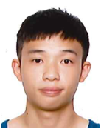 | Born: 22 Oct. 1993  Height 166cm  Riding Weight 47.5kg | 1 year (2014~) | · Last Year: 161(9/13/9, 5.6%)  · Lifetime: 161(9/13/9, 5.6%)
Fuma  Matsuwaka  (JRA)  Japan | 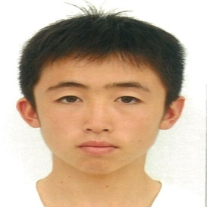 | Born: 4 Sep. 1995  Height 151cm Weight 42.7kg | 1 year  (2014 ~) | · This year: 418(35/20/26, 8.4%)  · Last Year: 603(47/44/40, 7.8%)  · Lifetime: 1,021(82/64/66, 8.0%)  ※ 2014 JRA Award Best Jockey (newcomer)  ※ 2015 Kokura Kinen(G3) Winner
Tsubasa  Sasagawa  (NAR)  Japan | 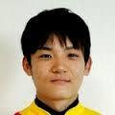 | Born: 1994  Height 164cm Weight 49kg | 2 years (2013~) | · Last Year: 919(60/62/73, 6.5%)  · Lifetime: 2,202(165/159/164, 7.5%)
Dong-Soo  Kim  (KRA, Seoul)  Korea | 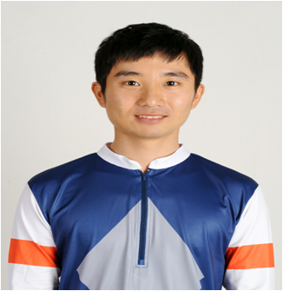 | Born: 24 Dec. 1986.  Height 157cm  Riding Weight 51kg | 1 year  (2014~) | · This year: 224(14/20/19, 6.3%)  · Last Year: 193(16/16/17, 8.3%)  · Lifetime: 417(30/30/36, 7.6%)

Name  (Country) | Photo | Personal  Information | Riding  Experience | Race Result (1st /2nd /3rd, Win Ratio)
Hee-Won  Jo  (KRA, Busan)  Korea | 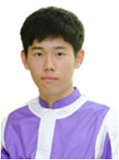 | Born: 1 Jul.1994  Height 165cm  Riding Weight 51kg | 1 year  (2014~) | · This year: 108(8/6/5, 7.4%)  · Last Year: 147(4/15/9, 2.7%)  · Lifetime: 255(12/21/14, 4.2%)
Yee Mo, Choi  (MJC)  Macau | 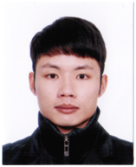 | Born: 1990  Height 161 cm  Riding Weight 51.5kg | 3 years  (2012~) | · This Season: 218(24/25/17, 11%)  · Last Season: 315(24/37/34, 7.6%)  · Lifetime: 1014(77/115/86, 7.6%)  ※ Macau Champion Apprentice (2013, 2014)  ※ Autumn Trophy on Luen Yat  Everwin (GⅡ, 2014) Winner
Wong Kam Chong  (MRA)  Malaysia | 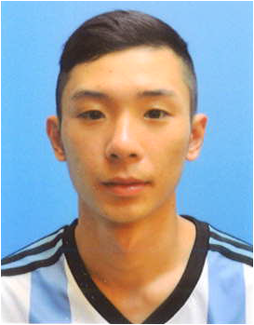 | Born: 4 Nov. 1991  Height 167cm  Riding Weight51kg | 2 years (2014~) | · This Year: 159(30/23/19, 18.8%)  · Last Year: 112(14/14/10, 12.5%)  · Lifetime: 271(44/37/29, 16%)  ※ 2015 Mitavite Cup Winner
Joshua Oliver  (NZTR)  New Zealand | 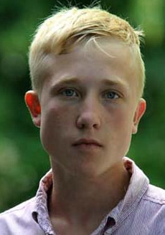 | Born: 6 Jan.1996  Height 159cm  Riding Weight 51kg | 3 years  (2012~) | · This Year: 11(0/0/0, 0%)  · Last Year: 390(27/20/36, 6.9%)  · Lifetime: 661(37/32/57, 5.6%)
Zhi Yong, See  (STC)  Singapore | 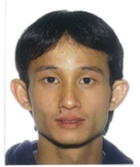 | Born: 12 Feb. 1983  Height 163cm  Riding Weight 49.5kg | 6 years  (2009~) | · This Year: 132(10/3/8, 7.6%)  · Last Year: 296(24/20/29, 9.9%)  · Lifetime: 863(56/42/54. 6.5%)
Craig, Zackey  (SAJA)  South Africa | 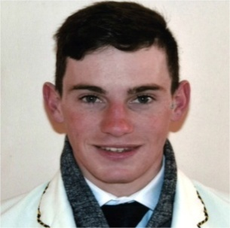 | Born: 7 Apr. 1995  Height 166cm  Riding Weight 52.5kg | 3 years  (2012~) | · This Year: 657(58/51/46, 8.8%)  · Lifetime: 1599(126/116/125, 7.9%)  ※ Arabian Beat(GⅠ), J’s outsider(GⅡ)  Winner  ※South African Champion Apprentice (14/15 season)

